Junior Maths Extension Course

Number

Table of contents
Contents
Facts to know 4
Divisibility rules 7
Questions 8
Answers 9
Sieve of Eratosthenes 11
Distribution of primes 12
Ulam’s prime spiral 14
Euler and Fermat – prime numbers 16
Euler’s prime-generating function 16
Fermat’s Little Theorem 16
Questions 16
Answers 17
How many factors 18
To start: 18
Notes 18
Questions 19
Follow-up starter 19
Answers 20
Finding the sum of factors of a number 21
Questions 22
Answers 23
Finding lowest common multiple and highest common factor 24
Questions 24
Answers 25
Number revision 26
Answers 27
Number progress test 28
Answers 32
Problem solving with LCM 33
LCM Questions 35
LCM Answers 37
Problem solving with common factors 39
Common factor questions 40
Common factor answers 41
Factoring and cryptography 42
Questions 43
Answers 44
Proportion problems 45
Questions 46
Answers 47
Modulus arithmetic 49
Questions 51
Answers 52
Rates 53
Questions 54
Answers 57
Ratio 59
Simplifying ratios 59
Sharing in a given ratio 59
Questions 60
Answers 62
Starter problems covering ratio and measurement 64
Answers 65
Direct proportion 66
Inverse proportion 66

Facts to know
Square numbers up to 20 Cubic numbers up to 10
13² = 169 1³ = 1
14² = 196 2³ = 8
15² = 225 3³ = 27
16² = 256 4³ = 64
17² = 289 5³ = 125
18² = 324 6³ = 216
19² = 361 7³ = 343
40² = 400 8³ = 512
9³ = 729
Powers of 2 10³ = 1000
2¹ = 2
2² = 4 Square roots
2³ = 8 $\sqrt{3}=1.732$
2⁴ = 16 $\sqrt{2}=1.414$
2⁵ = 32 $\sqrt{5}=2.236$
2⁶ = 64
2⁷ = 128
2⁸ = 256
2⁹ = 512
2¹⁰ = 1024

Ratio triangles
Investment Game
45º
45º
1
1
$$\sqrt{2}$$
30º
60º
1
2
$$\sqrt{3}$$
You have been given $5000 to invest as you wish.
A dice will be rolled to determine how well the financial year has treated investors. Round your results to the nearest dollar.
At the end of each year, you must cash in all assets and reinvest.

At the end of each year, calculate the percentage profit/loss you have made.
Dice Bank Account Shares Property Antiques Gambling Emus
1 7% -21% 18% -3% 460% -80%
2 12% 65% 26% 8% -90% -100%
3 6% -27% -12% 31% 30% 320%
4 4% 9% 15% 7% -57% -75%
5 8% 35% 19% 21% -100% 115%
6 6% -14% 24% 17% -85% 10%

 | Year 1  Investment | End year  Value | Year 2  Investment | End year  Value | Year 3  Investment | End year  Value
Bank
Shares
Property
Antiques
Gambling
Emus
TOTAL
 | % change: |  | % change: |  | % change:

 | Year 4  Investment | End year  Value | Year 5  Investment | End year  Value | Year 6  Investment | End year  Value
Bank
Shares
Property
Antiques
Gambling
Emus
TOTAL
 | % change: |  | % change: |  | % change:

Teaching suggestions:

Go over converting percentages to decimals, then increasing/decreasing by percentages in one step.
For first year, write up the numbers to multiply by for each investment, but for subsequent years get students to give the numbers.

After each year, give students a few minutes to calculate their new totals and the percentage increase/decrease. May need to revise how to calculate one number as a percentage of another.

After each year, select one student and get them to read out their new investment total, as well as the percentage increase/decrease they had since the previous year. Rest of class then tries to work out what that student had at the beginning of the year. May need to revise how to do this for the first year.

To incorporate ratios, for some years make the students invest in a given ratio. For example, one year they could be forced to invest into three different investments in the ratio 2:6:7.

Divisibility rules
Here are the basic divisibility rules when checking to see if a number is divisible by a number from 2-11:
Dividing by 2 | Last digit is 0, 2, 4, 6 or 8 | 123236 is divisible by 2
Dividing by 3 | Sum of digits is divisible by 3 | 345 is divisible as 3+4+5=12
Dividing by 4 | Last two digits form a number divisible by 4 | 2345628 is divisible by 4 as 28 is divisible by 4
Dividing by 5 | Last digit is 0 or 5 | 12345 and 345670 are divisible
Dividing by 6 | Number is divisible by both 2 and 3. So sum of digits is divisible by 3 and last digit is 0, 2, 4, 6 or 8 | 34650 is divisible by 6 as 3+4+6+5+0=18, 1+8=9 so divisible by 3, ends in 0
Dividing by 7 | Remove the last digit from the number, then subtract double that digit from the new number formed. If this new number is divisible by 7 or is zero, the original is also divisible by 7 | 154 is divisible by 7, since 15-(2x4)=7  1428 is divisible by 7. 142-(2x8)=126, then 12-(2x6)=0
Dividing by 8 | Last three digits form a number divisible by 4 | 2345016 is divisible by 8 as 016 is also
Dividing by 9 | Sum of digits is divisible by 9 | 12348 is divisible because 1+2+3+4+8=18
Dividing by 10 | Last digit is 0 | 23456780
Dividing by 11 | Difference between the sum of digits in odd positions and the sum of digits in even positions is zero or a multiple of 11 | 5536278 is divisible because (5+3+2+8)-(5+6+7)=0

Questions
- Is 417 divisible by 3?
- Is 5647 divisible by 7?
- Is 347292 divisible by 9?
- What is the remainder when 7638 is divided by 11?
- For what values of a is the number $463a8$ divisible by 3?
- For what values of a is the number $a7492541$ divisible by 11?
- Show that there is no value for a for which the number $8287a49$ is divisible by 11.
- Using the digits indicated below, construct a 4-digit number which has the following properties:
The number formed by the first digit is divisible by 1
The number formed by the first two digits is divisible by 2
The number formed by the first three digits is divisible by 3
The whole 4-digit number is divisible by 4
  - Using 2, 3, 4, 5
  - Using 2, 3, 7, 8
  - Using 0, 4, 6, 9
- Using the digits 1, 2, 3, 4, 5, 6, construct a 6-digit number which has the following properties:
The number formed by the first digit is divisible by 1
The number formed by the first two digits is divisible by 2
The number formed by the first three digits is divisible by 3
The number formed by the first four digits is divisible by 4
The number formed by the first five digits is divisible by 5
The number formed all six digits is divisible by 6
- Using all digits from 1-9, see if you can construct a 9-digit number which follows all of the rules as indicated in the previous questions (divisibility up to 9 this time)

Answers
- Is 417 divisible by 3?
Yes, because 4+1+7=12 which is divisible by 3
- Is 5647 divisible by 7?
No. 564-(2x7)=550. 55-(2x0)=55 which is not divisible by 7.
- Is 347292 divisible by 9?
Yes, because 3+4+7+2+9+2=27 which is divisible by 9
- What is the remainder when 7638 is divided by 11?
The remainder is 4, because (7+3)-(6+8)=-4. This means the number would have to be 4 less to be divisible by 11 (such as 7634).
- For what values of a is the number $463a8$ divisible by 3?
We know that 4+6+3+a+8=21+a. Since a must be a single digit, it can only be 0, 3, 6 or 9, as this makes the sum of the digits divisible by 3.
- For what values of a is the number $a7492541$ divisible by 11?
We know (a+4+2+4)-(7+9+5+1) = 10+a-22 = a-12
Since the difference must be either zero or a multiple of 11, the only way to get a-12 to work is for a to be 1. That way the difference is -11, which means it is divisible.
- Show that there is no value for a for which the number $8287a49$ is divisible by 11.
We know (8+8+a+9)-(2+7+4) = a+25-13 = a+12
There is no way for a to equal a positive single-digit integer which makes a+12 zero (requires a-12) or a multiple of 11 (requires a=-1 or a=10). Therefore is no value of a that will make the number divisible by 11.
- Using the digits indicated below, construct a 4-digit number which has the following properties:
The number formed by the first digit is divisible by 1
The number formed by the first two digits is divisible by 2
The number formed by the first three digits is divisible by 3
The whole 4-digit number is divisible by 4
  - Using 2, 3, 4, 5
Since the full number has to be divisible by 4, the last two digits can only be 24, 32 or 52. Number in position 2 has to be even, and the first three digits have to add to a multiple of 3. Therefore only solutions are 3452 and 5432.
  - Using 2, 3, 7, 8
Positions 2 and 4 need to be filled with even numbers. Digits in positions 3 and 4 need to form a number divisible by 4, so must be 32 or 72 as can’t be 28 since the 2 is needed in position 2. The sum of the first three digits must be a multiple of 3, therefore the only solutions are 7832 and 3872
  - Using 0, 4, 6, 9
Only solutions are 9604 and 9064
- Using the digits 1, 2, 3, 4, 5, 6, construct a 6-digit number which has the following properties:
The number formed by the first digit is divisible by 1
The number formed by the first two digits is divisible by 2
The number formed by the first three digits is divisible by 3
The number formed by the first four digits is divisible by 4
The number formed by the first five digits is divisible by 5
The number formed all six digits is divisible by 6
We know digits 2, 4 and 6 must be even. The first 3 digits must sum to a multiple of 3, which means the second 3 digits must also sum to a multiple of 3. The digits in the 3rd and 4th positions must form a 2-digit number divisible by 4. Therefore two answers are 123654 and 321654
- Using all digits from 1-9, see if you can construct a 9-digit number which follows all of the rules as indicated in the previous questions (divisibility up to 9 this time)
The number is 381654729

Sieve of Eratosthenes
Eratosthenes was a Greek scholar who lived in the third century BCE. He was a polymath, which means he excelled at a wide range of subjects, not just maths. He held the prestigious role of Head Librarian of the Library of Alexandria. Eratosthenes was known for many achievements, particularly for his work in geography and history. However, we mostly know him for his ‘sieve’, a technique for finding prime numbers.
The technique involves taking a grid of numbers (such as below), and firstly crossing off 1. Circle the first available number (2), then cross off all multiples of 2.
Find the next available number, circle it, then cross off all multiples of it. Repeat this until you run out of patience!
Those numbers remaining will be the primes.

Try this for the grid below:
1 | 2 | 3 | 4 | 5 | 6 | 7 | 8 | 9 | 10
11 | 12 | 13 | 14 | 15 | 16 | 17 | 18 | 19 | 20
21 | 22 | 23 | 24 | 25 | 26 | 27 | 28 | 29 | 30
31 | 32 | 33 | 34 | 35 | 36 | 37 | 38 | 39 | 40
41 | 42 | 43 | 44 | 45 | 46 | 47 | 48 | 49 | 50
51 | 52 | 53 | 54 | 55 | 56 | 57 | 58 | 59 | 60
61 | 62 | 63 | 64 | 65 | 66 | 67 | 68 | 69 | 70
71 | 72 | 73 | 74 | 75 | 76 | 77 | 78 | 79 | 80
81 | 82 | 83 | 84 | 85 | 86 | 87 | 88 | 89 | 90
91 | 92 | 93 | 94 | 95 | 96 | 97 | 98 | 99 | 100

Distribution of primes
We count in base 10. However, there are lots of other bases out there. One example would be base 8. This means that when we reach 8 we must write it as 10. Counting up would look like this: 1, 2, 3, 4, 5, 6, 7, 10, 11, 12, 13, 14, 15, 16, 17, 20, 21…
What numbers would be prime in base 8?
Use the base-specific Sieves of Eratosthenes below and see what happens.
Base-8 Primes
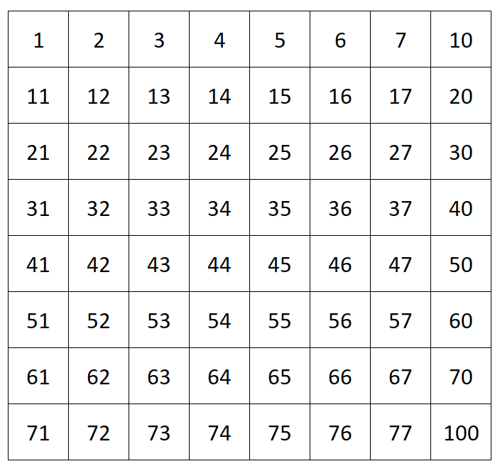
What about staying in base 10 but changing the width of the grid? What do you notice about the prime distribution when it is 6 squares wide? Why do you think this happens?
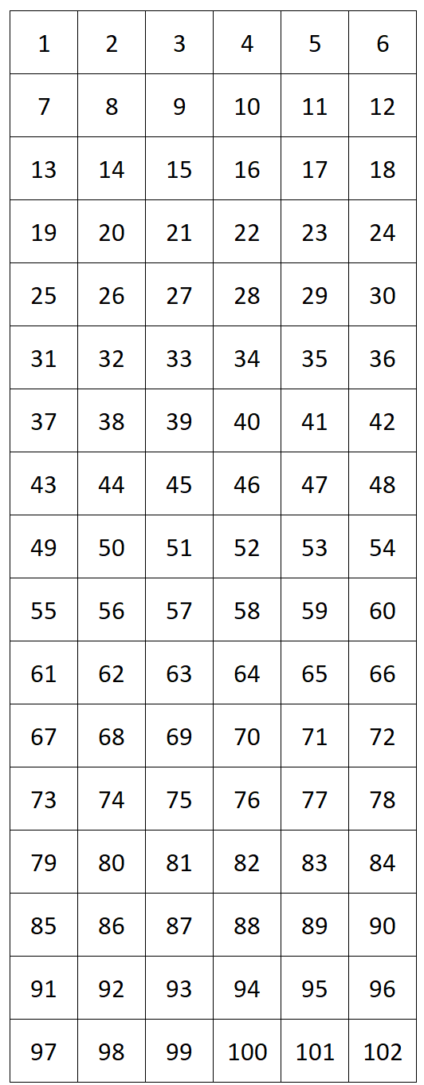

For an explanation, consider the table below which shows remainders when divided by 6. You can see that for a number to have a remainder of 0, 2 or 4 it must be a multiple of 2. Similarly, numbers giving a remainder of 0 or 3 must be multiples of 3. Other than 2 and 3 themselves, those numbers are therefore all composite (not prime).
This means that all primes greater than 3 must have a remainder of 1 or 5 when divided by 6. In other words, they are either one less or one greater than a multiple of 6. Obviously, not all numbers either side of 6 will be prime, but it is a great place to start looking!
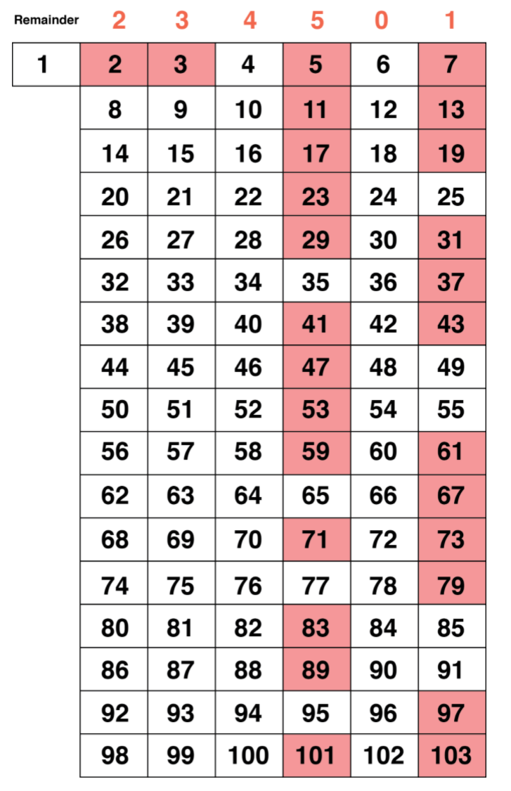

Ulam’s prime spiral
Mathematician Stanislaw Ulam was a student doodling during a boring lecture, drawing integers in an ever-growing spiral when he noticed a striking pattern of the primes.
He started in this pattern:
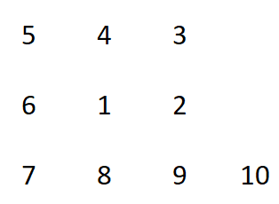
In the spiral below, use your knowledge of divisibility rules to highlight the primes. Is there any pattern that you notice?
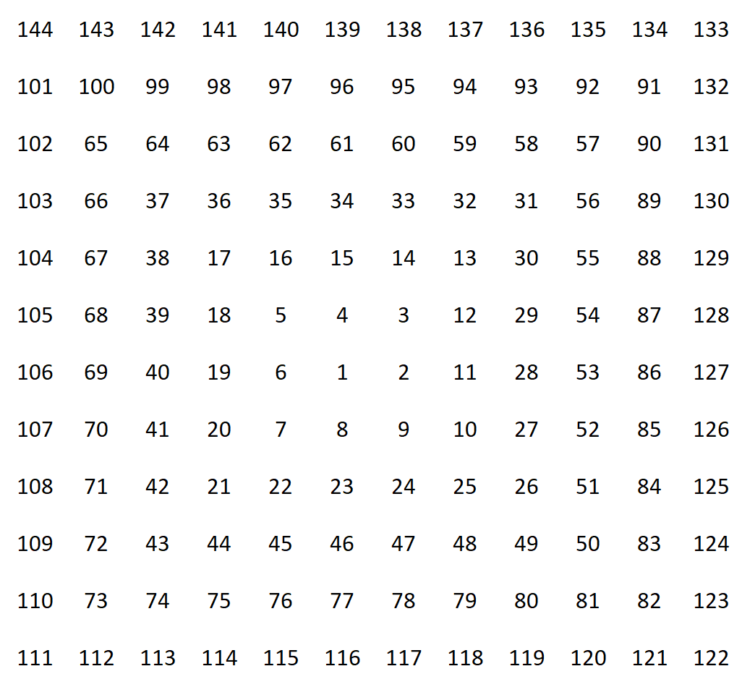
Have a look at what happens when we start with 41 in the centre of the spiral.
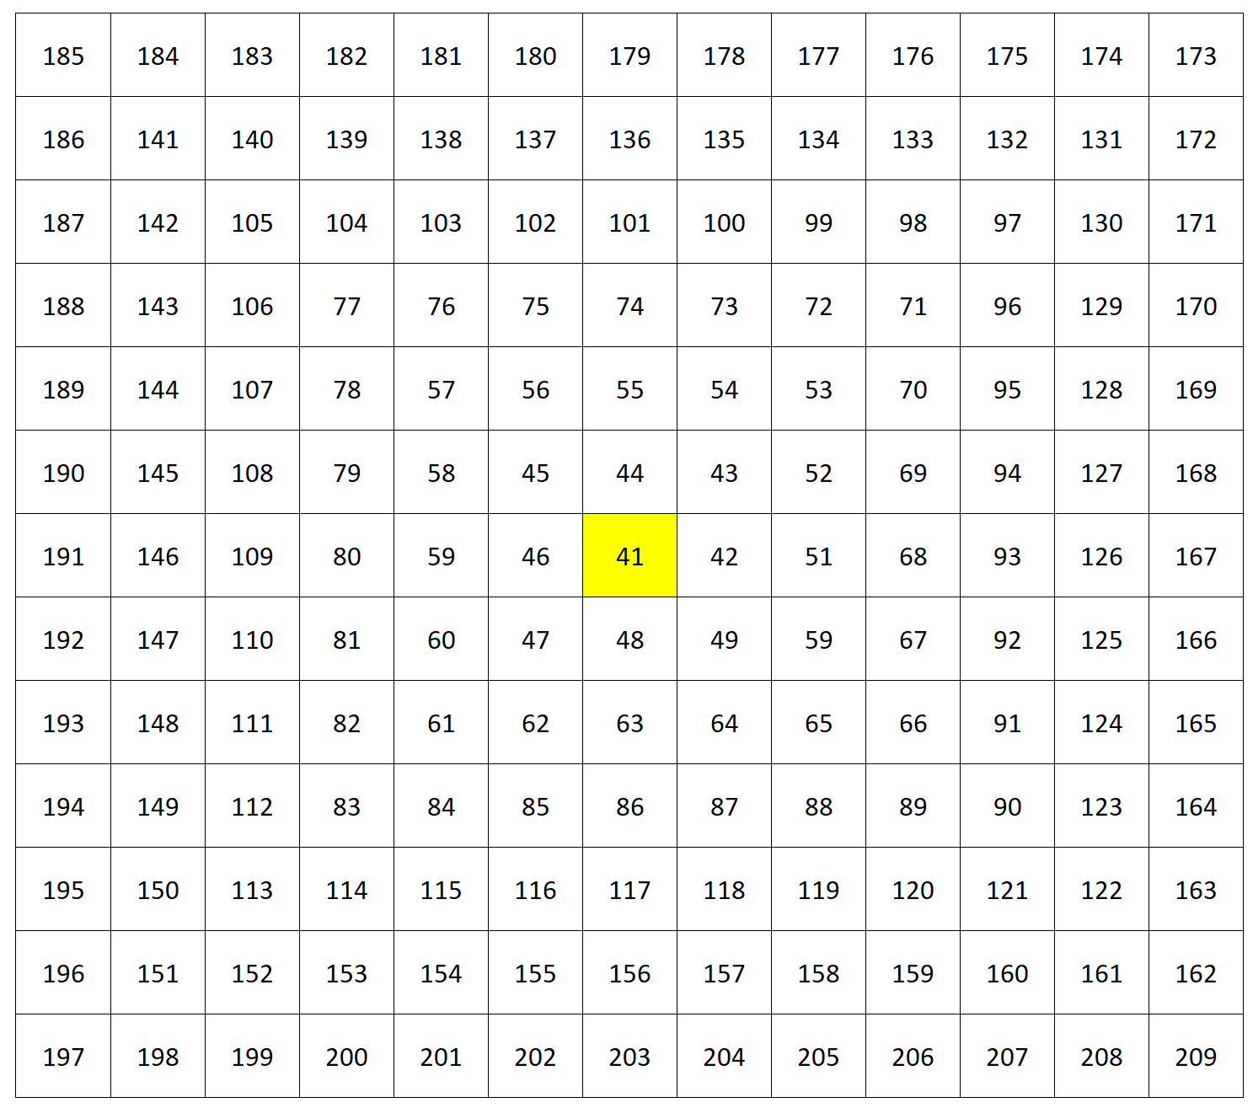

Look at a larger spiral where the primes are highlighted. Nobody knows why this happens!

Great Numberphile video on prime spirals: https://www.youtube.com/watch?v=iFuR97YcSLM&ab_channel=Numberphile
More on why 41 is amazing:
https://www.youtube.com/watch?v=3K-12i0jclM&t=0s&ab_channel=Numberphile
(Leads on nicely to the Euler and Fermat lesson)
Continuing to play with the possibilities, notice the visible diagonal, horizontal and vertical lines with a high density of prime numbers when we start at 41 in the centre.
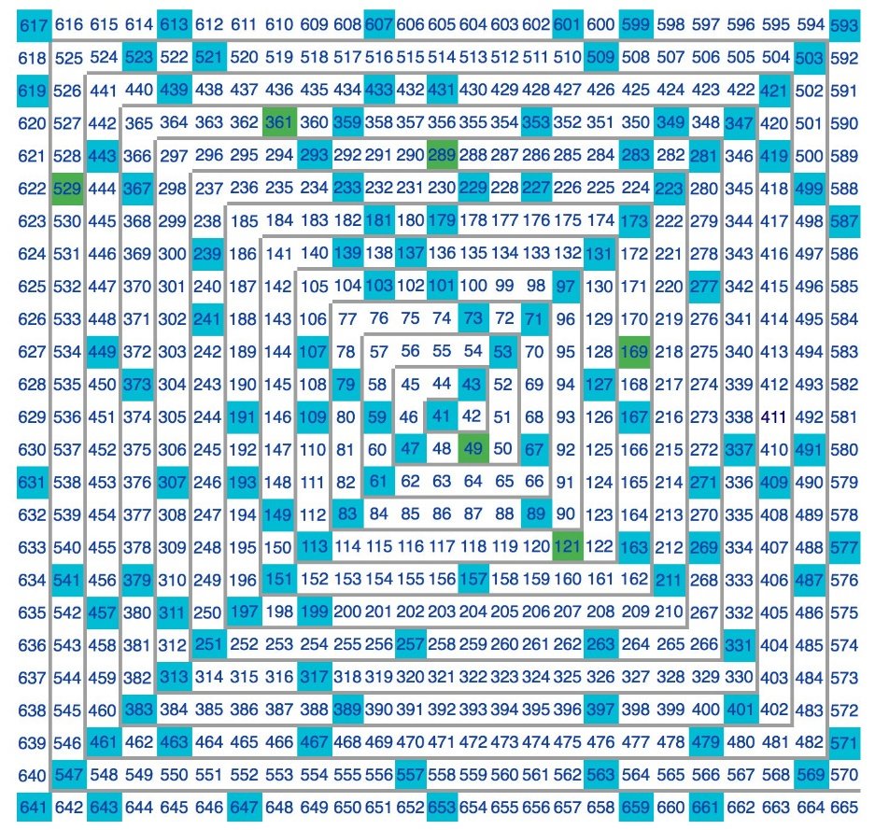

Euler and Fermat – prime numbers

Euler’s prime-generating function
In 1772, Leonhard Euler noticed that the polynomial $P\left(n\right)=n^{2}-n+41$ generates prime numbers for certain values of n.
For example, if n=2, we get $P\left(2\right)=2^{2}-2+41=43$
Find a value of n where Euler’s formula fails to generate a prime number.

Fermat’s Little Theorem
Pierre de Fermat, famous for his so-called “Last Theorem”, did a lot of work on prime numbers also.
His “Little Theorem”, named in order to differentiate it from his more famous Last Theorem, states that in order to be prime, a number p must pass this test:
If p is a prime number, then for any integer a, the number $a^{p}-a$ must be a multiple of p. (a can range from 2 to p-1)
For example, the number 3 is a prime because for any integer value of a up to 2, we can see that $a^{3}-a$ will be a multiple of 3.
$$1^{3}-1=0 \\ 2^{3}-2=6 \\ 3^{3}-3=24$$
If a number fails any of these tests, it cannot be prime.
For example, the number 9:
$2^{9}-2=510$ Not divisible by 9, therefore 9 is not a prime
In this case 2 is called a witness, as it has verified that 9 can’t be prime. Composite numbers will pass for some values of a, such as $7^{9}-7=40,353,600$, which is divisible by 7. When this happens, the value for a is called a Fermat’s liar. So for the number 9, 2 is a witness and 7 is a liar.
However, if it passes for all values of a, then it may be a prime (but not necessarily). In this case, it requires further investigation.
Great video: https://www.youtube.com/watch?v=jbiaz_aHHUQ&ab_channel=Numberphile

Questions
Use Fermat’s Little Theorem to show that 5 may be a prime number, trying values of a up to and including 5.
Use Fermat’s Little Theorem to find a witness to show that the following cannot be prime. Also find a liar for 6 and 12:
- 4
- 6
- 12

Answers
Number when Euler’s formula doesn’t generate a prime:
N=41
${41}^{2}-41+41={41}^{2}$ therefore can’t possibly be prime.

Use Fermat’s Little Theorem to show that 5 may be a prime number, trying values of a up to and including 5.
$$2^{5}-2=30 \\ 3^{5}-3=240 \\ 4^{5}-4=1020$$

Use Fermat’s Little Theorem to show that the following cannot be prime:
4
$2^{4}-2=14$ 2 is a witness. Not divisible by 4 therefore 4 cannot be prime.
6
$2^{6}-2=62$ 2 is a witness. Not divisible by 8 therefore 8 cannot be prime
$3^{6}-3=726$ 3 is a liar as 726 is divisible by 6

12
$2^{12}-2=4094$ 2 is a witness. Not divisible by 12 (not divisible by 3) therefore not prime$4^{12}-4=16,777,212$ Divisible by 12, therefore 4 is a liar.

How many factors

To start:
How many factors does each of the following numbers have?
7
20
36
50
120

Write out the prime factorisation of each, using index notation (powers). Feel free to use factor trees if necessary.
Look at the prime factorisation and the number of factors for each number. What is the relationship? Why would this be the case?

Notes
To find how many factors a number has, write out its prime factorisation (including powers). Then, add one to each power and multiply them together.
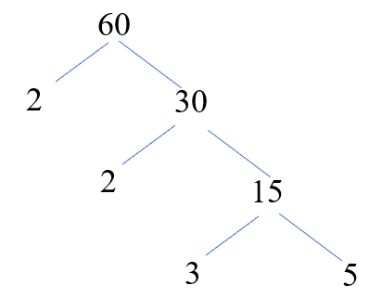
e.g. How many factors does 60 have?

$$60=2^{2}×3^{1}×5^{1}$$

So, the prime factorisation of 60 is
Taking the powers, adding one to each, then multiplying, gives 3 x 2 x 2 = 12 factors.

Questions
Using this relationship, find how many factors the following numbers have:
80
24
108
360

Find all numbers less than 100 that have exactly n factors for the following values of n:
4
10
12
15

What is the lowest number above 300 that has 6 factors?

The number 561 has 3 prime factors. Has many non-prime (composite) factors does it have?

What is the smallest number with 16 factors?

What is the greatest 3-digit number with 8 factors?

How many factors does the product $1×2×3×4×5×6×7×8×9×10×11×12$ have?

Follow-up starter
Highly composite numbers are those numbers that have more factors than any numbers less than them.
Identify all highly composite numbers up to 100.

Answers
Using this relationship, find how many factors the following numbers have:
80 = 10 factors
24 = 8 factors
108 = 12 factors
360 = 24 factors

Find all numbers less than 100 that have exactly n factors for the following values of n:
4 = 2^3 = 8, 3^3 = 27, n^1 x m^1, giving 2x3, 2x5, 2x7, 2x11, 2x13, 2x17, 2x19, 2x23, 2x29, 2x31, 2x37, 2x41, 2x43, 2x47, 3x5, 3x7, 3x11, 3x13, 3x17, 3x19, 3x23, 3x29, 3x31, 5x7, 5x11, 5x13, 5x17, 5x19, 7x11, 7x13 = 32 numbers
10 = m^4 x n^1, giving 16x3=48, 16x5=80
12 = m^5 x n^1, giving 32x3=96
m^3 x n^2, giving 8x9=72
15 = m^4 x n^2, giving 16x9 as the smallest, therefore none have 15 factors

What is the lowest number above 300 that has 6 factors?
$$2^{2}×{79}^{1}=316$$

The number 561 has 3 prime factors. Has many non-prime (composite) factors does it have?
$561=3^{1}×{11}^{1}×{17}^{1}$ Has 8 factors, therefore 5 are non-prime

What is the smallest number with 16 factors?
$$2^{1}×3^{1}×5^{1}×7^{1}=210$$

What is the greatest 3-digit number with 8 factors?
$$3^{3}×{37}^{1}=999$$

How many factors does the product $1×2×3×4×5×6×7×8×9×10×11×12$ have?
Write in index form: $2^{1}×3^{1}×2^{2}×5^{1}×(2^{1}×3^{1})×7^{1}×2^{3}×3^{2}×(2^{1}×5^{1)}×{11}^{1}×\left(2^{2}×3^{1}\right)=2^{10}×3^{5}×5^{2}×7^{1}×{11}^{1}$
Adding one to each power and multiplying, gives $11×6×3×2×2=792$
Follow-up starter:
1, 2, 4, 6, 12, 24, 36, 48, 60, 96

Finding the sum of factors of a number
This is related to finding how many factors a number has, so we need to first write it in prime factorisation form.

e.g. $24=2^{3}×3^{1}$
From this, we know that 24 has 4 x 2=8 factors.

$$2^{0}×3^{0}=1$$
$$2^{0}×3^{1}=3$$
$$2^{1}×3^{0}=2$$
$$2^{1}×3^{1}=6$$
$$2^{2}×3^{0}=4$$
$$2^{2}×3^{1}=12$$
$$2^{3}×3^{0}=8$$
$$2^{3}×3^{1}=24$$

Factorising:
$$\left(2^{0}+2^{1}+2^{2}+2^{3}\right)3^{0}+\left(2^{0}+2^{1}+2^{2}+2^{3}\right)3^{1}=\left(2^{0}+2^{1}+2^{2}+2^{3}\right)\left(3^{0}+3^{1}\right)$$

To find the sum of the factors, we now write out the sum of each prime factor as below:
$$\left(2^{0}+2^{1}+2^{2}+2^{3}\right)\left(3^{0}+3^{1}\right)$$
Notice how each bracket contains the ascending powers of the prime factor, starting from zero and going up to the highest index of the prime factorisation.
If we expanded these brackets, it would give us 4 x 2 = 8 factors:

The sum is therefore the product of the two brackets:
$$\left(1+2+4+8\right)×\left(1+3\right)=15×4=60$$

Questions
- Find the sum of the factors of the following numbers:
  - 36
  - 120
  - 200

Amicable numbers are related in such a way that the sum of their proper divisors (all factors except the number itself) of each is equal to the other number.
- Which of the following pairs are amicable?
  - 220 and 284
  - 60 and 168
  - 1184 and 1210

Perfect numbers are those numbers whose proper divisors add up to the number itself. For example, 6 is a perfect number because 1 + 2 + 3 = 6
Numbers are called abundant if the sum of their proper divisors is greater than the number itself. For example, 12 is abundant because 1 + 2 + 3 + 4 + 6 = 16 which is greater than 12.
Numbers are called deficient if the sum of their proper divisors is smaller than the number itself. For example, 8 is deficient as 1 + 2 + 4 = 7, which is less than 8.
- Calculate whether each of the following is perfect, abundant or deficient:
  - 18
  - 9
  - 496
  - 40
  - 14
  - 28

Answers
- Find the sum of the factors of the following numbers:
  - 36 = $2^{2}×3^{2}=\left(2^{0}+2^{1}+2^{2}\right)\left(3^{0}+3^{1}+3^{2}\right)=7×13=91$
  - 120 = $2^{3}×3^{1}×5^{1}=\left(2^{0}+2^{1}+2^{2}+2^{3}\right)\left(3^{0}+3^{1}\right)\left(5^{0}+5^{1}\right)=15×4×6=360$
  - 200 = $2^{3}×5^{2}=\left(2^{0}+2^{1}+2^{2}+2^{3}\right)\left(5^{0}+5^{1}+5^{2}\right)=15×31=465$

Amicable numbers are related in such a way that the sum of their proper divisors (all factors except the number itself) of each is equal to the other number.
- Which of the following pairs are amicable?
- 220 has proper divisors that sum to 284
284 has proper divisors that sum to 220
Therefore 220 and 284 are amicable

- 60 has proper divisors that sum to 168
168 has proper divisors that do not sum to 60
Therefore 60 and 168 are not amicable
- 1184 has proper divisors that sum to 1210
1210 has proper divisors that sum to 1184
Therefore they are amicable

- Calculate whether each of the following is perfect, abundant or deficient:
  - 18 = Abundant
  - 9 = Deficient
  - 496 = Perfect
  - 40 = Abundant
  - 14 = Deficient
  - 28 = Perfect

Finding lowest common multiple and highest common factor

Any number can be expressed as the product of prime factors using index notation.
For example, $20=2^{2}×5^{1}$, $24=2^{3}×3^{1}$

Finding the LCM
To find the lowest common multiple (LCM) of two numbers, we simply find all factors represented, with their largest index.
For example, the LCM of 20 and 24 will be: $2^{3}×3^{1}×5^{1}=120$

Finding the HCF
To find the highest common factor (HCF) of two numbers, we simply use only the common factors, with the smallest index.
For example, the HCF or 20 and 24 will be: $2^{2}=4$

Questions
Find the LCM of the following numbers:
- 90 and 200
- 80 and 96
- 180, 300 and 360
- 1, 2, 3, 4, 5, 6, 7, 8, 9, 10

Find the HCF of the following numbers:
- 90 and 200
- 80 and 96
- 180, 300 and 360
- 252, 378 and 792

Answers
Find the LCM of the following numbers:
- 90 and 200
$$90=2^{1}×3^{2}×5^{1} \\ 200=2^{3}×5^{2}$$Therefore the LCM is $2^{3}×3^{2}×5^{2}=1800$
- 80 and 96
$$80=2^{4}×5^{1} \\ 96=2^{5}×3^{1}$$Therefore, the LCM is $2^{5}×3^{1}×5^{1}=480$
- 180, 300 and 360
$$180=2^{2}×3^{2}×5^{1} \\ 300=2^{2}×3^{1}×5^{2} \\ 360=2^{3}×3^{2}×5^{1}$$Therefore, the LCM is $2^{3}×3^{2}×5^{2}=1800$
- 1, 2, 3, 4, 5, 6, 7, 8, 9, 10
Factors are: $2^{1}, 3^{1}, 2^{2}, \left(2^{1}×3^{1}\right), 7^{1}, 2^{3}, 3^{2}, (2^{1}×5^{1)}$
Therefore, the LCM is $2^{3}×3^{2}×5^{1}×7^{1}=2520$
Find the HCF of the following numbers:
- 90 and 200
$$90=2^{1}×3^{2}×5^{1} \\ 200=2^{3}×5^{2}$$Therefore the HCF is $2^{1}×5^{1}=10$
- 80 and 96
$$80=2^{4}×5^{1} \\ 96=2^{5}×3^{1}$$Therefore, the HCF is $2^{4}=16$
- 180, 300 and 360
$$180=2^{2}×3^{2}×5^{1} \\ 300=2^{2}×3^{1}×5^{2} \\ 360=2^{3}×3^{2}×5^{1}$$Therefore, the HCF is $2^{2}×3^{1}×5^{1}=60$
- 252, 378 and 792
$$252=2^{2}×3^{2}×7^{1} \\ 378=2^{1}×3^{3}×7^{1} \\ 792=2^{3}×3^{2}×{11}^{1}$$Therefore, the HCF is $2^{1}×3^{2}=18$

Number revision
- Write the prime factorisation for 1800 in index form.

- How many factors does 1800 have?

- How many factors does 999 have?

- List all 3-digit numbers with exactly 5 factors.

- List all 2-digit numbers with exactly 6 factors.

- What is the sum of the factors of 180? Note: this can be written as $2^{2}×3^{2}×5^{1}$

- Show that 28 is a perfect number.

- Expressing your answer in prime factorisation form only, find the HCF and LCM of $2^{2}×3^{5}$ and $2^{3}×3^{3}$.

- Expressing your answer in prime factorisation form only, find the HCF and LCM of $2^{45}×5^{15}×{13}^{2}$ and $2^{32}×5^{10}×7^{2}×{13}^{4}$.

- Which two numbers have a HCF of $2^{3}×3^{2}$ and an LCM of $2^{5}×3^{3}$? You can express your answer in prime factorisation form.

- Which two numbers have a HCF of $2^{13}×5^{3}$ and an LCM of $2^{15}×3^{3}×5^{7}$? You can express your answer in prime factorisation form.

- Find any value(s) of a that will make the number 2a57538a73 divisible by 11

- Find value(s) of a that will make the number 6215a61a divisible by 9.

- Demonstrate the divisibility rule for 7 to show whether 40,353,600 is divisible by 7.

Answers
- $2^{3}×3^{2}×5^{2}$
- 4 x 3 x 3 = 36
- $999=3^{3}×{37}^{1}$= 8 factors
- $4^{4}=256, 5^{4}=625$
- $2^{5}=32$$$2^{3}×3^{1}=24, 2^{3}×5^{1}=40, 2^{3}×7^{1}=56, 2^{3}×{11}^{1}=88 \\ 3^{3}×2^{1}=54, {11}^{1}×3^{2}=99$$Lots more
- $\left(2^{0}+2^{1}+2^{2}\right)\left(3^{0}+3^{1}+3^{2}\right)\left(5^{0}+5^{1}\right)=7×13×6=546$
- $28=2^{2}×7^{1}$Sum of factors: $\left(2^{0}+2^{1}+2^{2}\right)\left(7^{0}+7^{1}\right)=7×8=56$
Subtracting 28 itself gives a sum of proper divisors of 28, therefore it is perfect (sum of proper divisors is equal to the number itself)
- HCF: $2^{2}×3^{3}$
LCM: $2^{3}×3^{5}$
- HCF: $2^{32}×5^{10}×{13}^{2}$
LCM: $2^{45}×5^{15}×7^{2}×{13}^{4}$
- $2^{3}×3^{3}$ and $2^{5}×3^{2}$ OR $2^{3}×3^{2}$ and $2^{5}×3^{3}$
- $2^{15}×3^{3}×5^{7}$ and $2^{13}×5^{3}$
$2^{13}×3^{3}×5^{7}$ and $2^{15}×5^{3}2^{13}×3^{3}×5^{3}$ and $2^{15}×5^{7}2^{15}×3^{3}×5^{3}$ and $2^{13}×5^{7}$
- $\left(2+5+5+8+7\right)-\left(a+7+3+a+3\right)=0 or 11$$$14-2a=0 or 11 \\ a=7$$
- Find value(s) of a that will make the number 6215a61a divisible by 9.
$$6+2+1+5+6+1+2a=21+2a$$So, 21+2a must be divisible by 9
Therefore, a=3 is the only solution
- 4,035,360 – 2x0 = 4,035,360
403,536 – 2x0 = 403,536
40,353 – 2x6 = 40,341
4,034 – 2x1 = 4,032
403 – 2x2 = 399
39 – 2x9 = 21
21 is divisible by 7, therefore the original number 40,353,600 is divisible by 7 also

Number progress test
- Prime factorisation and index form
- How many factors does a number have?
- Finding a number with a particular number of factors
- The sum of factors of a number
- Finding the HCF and LCM of a group of numbers
- Checking divisibility rules

You may NOT use a calculator in this test.
In all questions, show your working. Well-organised, easy to follow working is prized and rewarded!

Question 1
Write the prime factorisation for 1260 in index form.

Question 2
How many factors does 1260 have?

Question 3
List all 3-digit numbers with exactly 11 factors.

Question 4
List all 2-digit numbers with exactly 12 factors.

Question 5
What is the sum of the factors of 144? Note: this can be written as $2^{4}×3^{2}$

Question 6
Numbers are called abundant if the sum of their proper divisors is greater than the number itself. Give an example of an abundant number.

Question 7
Numbers are called deficient if the sum of their proper divisors is smaller than the number itself. Give an example of a deficient number.

Question 8
Expressing your answer in prime factorisation form only, find the HCF and LCM of $2^{4}×3^{2}×5^{1}$ and $2^{3}×3^{3}×5^{2}$.

Question 9
Expressing your answer in prime factorisation form only, find the HCF and LCM of $2^{14}×7^{5}×{11}^{3}$ and $2^{30}×7^{3}×5^{2}×{11}^{1}$.

Question 10
Which two numbers have a HCF of 432 $(2^{4}×3^{3})$ and an LCM of 15,552 $(2^{6}×3^{5})$? You can express your answer in prime factorisation form.

Question 11
Find a value of a that will make the number 5638a21 divisible by 11

Question 12
Find value(s) of a that will make the number 435a68a divisible by 6.

Answers
Question 1
$$2^{2}×3^{2}×5^{1}×7^{1}$$
Question 2
3 x 3 x 2 x 2 = 36
Question 3
There are no 3-digit numbers with 11 factors. The smallest number with exactly 11 factors is $2^{10}=1024$, which has 4 digits.
Question 4
Can be in the form $a^{11}$, $a^{5}×b^{1}$, $a^{3}×b^{2}$ or $a^{2}×b^{1}×c^{1}$
Only numbers that work are $2^{5}×3^{1}=96, 2^{3}×3^{2}=72, 2^{2}×3^{1}×5^{1}=60$, $2^{2}×3^{1}×7^{1}=84,2^{1}×3^{2}×5^{1}=90$
Question 5
$$\left(2^{0}+2^{1}+2^{2}+2^{3}+2^{4}\right)\left(3^{0}+3^{1}+3^{2}\right)=31×13=403$$
Question 6
12 is abundant: 1 + 2 + 3 + 4 + 6 = 16
Question 7
8 is deficient: 1 + 2 + 4 = 7
Question 8
HCF = $2^{3}×3^{2}×5^{1}$
LCM = $2^{4}×3^{3}×5^{2}$
Question 9
HCF = $2^{14}×7^{3}×{11}^{1}$
LCM = $2^{30}×7^{5}×5^{2}×{11}^{3}$
Question 10
Numbers are $2^{4}×3^{5}$ and $2^{6}×3^{3}$
Question 11
(5 + 3 + a + 1) – (6 + 8 + 2) = 0 or 11
a – 7 = 0 or 11
a = 7
Question 12
a must be even and sum of digits must be divisible by 3. Therefore 4 + 3 + 5 + 6 + 8 + 2a = 2a + 26
a could be 0, 2, 4, 6, 8 to make number even, but only a = 2 and 8 give a sum that is divisible by 3

Problem solving with LCM
We can use the lowest common multiple to solve some pretty formidable problems.
The type of problem that can be solved using the LCM is where there is a task being completed by more than one contributor.
The strategy in these problems is to find the lowest common multiple of each number, and then calculate how much “work” could be done by all contributors in that time. Then we just divide the LCM by the total “work”.

For example: If John can build a house in six months and James can build it in 9 months, how long would it take for them to build it if they worked together?
Consider what John and James could accomplish if they both worked for 18 months, where 18 is the LCM of 6 and 9.
John could build the house completely 3 times.
James could build the house completely 2 times.
Therefore, between them they could build it 5 times in 18 months.
This means that they could build it once between them in 18/5 months, so in 3.6 months or 3 months 18 days approx.

An example with a “negative contributor”
A bath is empty. The cold tap can fill it in 10 minutes while the hot tap takes 12 minutes to fill it. When the plug is pulled the bath empties in 6 minutes. What will happen if both taps are turned on and the plug is not in the plughole? Will the bath fill, or remain empty?
Here the contributors are the two taps with the pulled plug being a negative one.
Consider what will happen in 60 mins, where 60 is the LCM of 10, 12, and 6.
Cold tap fills it 6 times, the hot tap 5 times, and bath empties 10 times.
Therefore, the bath fills once (6 + 5 - 10) in 60 mins.
To answer the question, the bath fills and takes 60 minutes to do so.

Passing trains example
Train A leaves Auckland station travelling to Hamilton and the journey takes 45 mins. A slower train leaves Hamilton at the same time, heading for Auckland on a journey that takes 65 mins. How long will it be before they meet?
Here the task to be completed is to cover the distance between the two cities, with the trains being the two contributors. When they meet, they have covered the journey between them.
Let both trains travel for 585 minutes since 585 is LCM of 45 and 65.
The AucklandHamilton train will cover the distance 13 times.
The HamiltonAuckland train will cover the distance 9 times
Therefore, they cover the journey 22 times between them in 585 mins, which means they meet after 585/22 mins. i.e. after 26 mins and 36 secs approx.

Passing swimmers example
Two swimmers leave the same end of a pool at the same time and plan to swim a number of lengths. Swimmer A can complete a length in 15 secs while it takes swimmer B 20 secs.
How long will it be before they meet again, heading in opposite directions of course?
When they meet again, they will have done two lengths equivalent between them. We proceed as above but we double the answer for time taken to cover two lengths rather than just one. Let both swimmers swim for 60 secs since it is the LCM of 15 and 20.
A
B
Swimmer A will complete 4 lengths
Swimmer B will complete 3 lengths
They complete 7 lengths between them in 60secs
Therefore, they complete one length between them in 60/7 secs and two lengths between them in 120/7 secs. They will meet again after 17.14 secs.

Inverse problems can be quickly solved by this method also.

For example: Two trains simultaneously set out from their respective stations, each travelling to the other one. They meet after 45 mins. One train can complete the whole trip in 63 mins.
How long does it take the other one to complete the whole trip?
We can use a similar approach to above. Simplify find the LCM of 63 and 45, which is 315. Now, consider what would happen in this time.
Between them, they would complete 7 trips, since 315/45=7.
But one train does 5 trips in that time, since 315/63=5.
This means that the other train would complete 2 trips in the 315 minutes, so it must take 157.5 minutes to complete one trip.

LCM Questions
- Jack can paint a house in 5 days while Jill can paint the same house in 7 days.
How long will it take the pair of them working together?

- It takes Bill 3 hrs to load a truck with firewood, Jane 5 hrs to do the same job, while Johnny can load the truck in 6 hrs.
How long in hours and minutes would it take the three of them working together?

- Two ferry boats travel between Auckland and Devonport. They leave from the two terminals at the same time, with the one leaving Auckland taking 12 minutes to Devonport, while the one leaving Devonport takes 10 minutes to get to Auckland.
How long will it be in minutes and seconds before they meet?
- Two athletes decide to run the 400m track in different directions. If Athlete A runs 400m in 52 secs and Athlete B runs 400m in 48 secs, how long will it be before they meet each other? How far has each runner covered?
- If the hot tap can fill a bath in 8 mins, while the cold tap can fill the same bath in 10 mins, how long will it take both taps to fill the bath if they are turned on together (and the plug is in)?

- A bath is full of water and the plug is in. The hot tap can fill the bath in 6 mins, while the cold one takes just 4 mins.
If the bath can empty in just 3mins, what will happen if both taps are turned on and the plug pulled all at the same time?

- Pat and Andy working together can complete a job in 9hrs. Pat knows he can do the job by himself in 15hrs.
How long would it take Andy, working by himself?

- Two trains leave Auckland and Wellington simultaneously. The train going to Auckland can complete the journey in 12 hours while the one leaving Wellington can complete the journey in 16 hours.
After how long will they meet?

- Two swimmers leave the same end of a pool at the same time intending to swim a few lengths. Swimmer A can swim lengths in 25 secs while swimmer B swims lengths in 30 secs.
When will they meet each other again, going in opposite directions?
- Two trains travelling simultaneously between the same two stations in opposite directions, meet after they have been travelling 3 hours.
If they began their journeys together, and one train can complete the whole journey in 5 hours, how long does it take the other train to complete the full journey?

- A houseowner has to have his house painted in a working week i.e. 5 days. One painter says he could do the job in 10 days, while a second painter reckons it would take him 18 days. To guarantee completion of the job he employs both painters to start on Monday morning and hires a third painter to start then also.
Is the third painter needed? If so, in how many days would he have to be able to do the job to ensure all three complete it on time?

LCM Answers
1. 35/12 days or 2.917 days

2. Consider what would happen in 30 hrs.
Bill 10 times, Jane 6 times, Johnny 5 times.
Time together = 30/21 hrs
= 1.4285 hrs
= 1 hr 26 min approx.

3. 60/11 mins or 5.4545 mins
=5 mins 27secs approx.

4. Consider what happens in 624 mins
A runs 12 laps, B runs 13 laps
Time to complete one lap between them = 624/25
= 25secs approx.
A has covered 25/52 of 400 = 192 m approx.
B has covered 25/48 of 400 = 208 m approx.

5. 40/9 mins = 4.444…mins or 4mins 27 secs approx.

6. Consider what would happen in12 mins.
It would fill 5 times (2 hot and 3 cold) and empty 4 times. Nett gain of water.
Therefore, the bath would overflow.

7. Consider 45 hrs.
Together 5 times.
Pat by himself 3 times.
Therefore, Andy twice in 45 hrs
i.e. once in 22.5 hrs

8. 48/7 hrs = 6.857hrs, or 6 hrs 51mins approx.

9. Consider what would happen in 150 secs
A completes 6 laps, B 5 laps.
Time taken to complete length equivalent = 150/11secs
Time for 2-lap equivalent is 300/11 = 27.2727secs.
They meet again after 27.27secs approx.

10. Consider what would happen in 15 hrs.
They would do 5 completions between them
But one train would do 3
Therefore, the other train does 2 in 15 hrs
Other train would take 7.5 hrs to complete journey.

11. Consider using just the first two painters.
They could complete painting in 90/14 days
i.e. in 6.42857 days.
They do need third painter.
The required rate is one house painted in 5 days, or 18 times in 90 days
Therefore, the third painter has to offer at least 4 times in 90 days.
Third painter has to be able to do job in 22.5 days

Problem solving with common factors
We can use prime factorising and common factors to solve some pretty challenging problems also.
Typically, these involve numbers that are multiples of the same number(s).

For example: Jenny buys some CD’s for $161, while Sally paid $207 for a number of identically priced CD’s. What was the price of a CD?
Now the price of a CD must be a common factor of 161 and 207, but not necessarily the highest one.
We start by doing the prime factorisation of each number.
161 = 7 x 23
207 = 3 x 3 x 23
So, assuming CD’s do not cost $1, we can conclude they must cost $23 as that is the only common factor.

And a harder example:
At the beginning of a season, a coach bought a number of boxes of balls for $336, while another bought identical boxes of balls for $504. Given that balls cost between $30 and $50, what is the price of a box of balls?
Again, we start by doing the prime factorisation of each number.
336 = 2 x 2 x 2 x 2 x 3 x 7
504 = 2 x 2 x 2 x 3 x 3 x 7
The highest common factor is 2 x 2 x 2 x 3 x 7 = 168, which is too high as we know the balls must cost between $30 and $50. So, we look for common prime factors that will multiply to give a value in that range.
In this case, 2 x 3 x 7 = 42, so a box of balls will cost $42.

Common factor questions

- Anne bought a number of CD’s for $168 while Simon bought a selection of the same-priced CD’s for $231. What was the likely price of the CD’s?
- Two families, all adults, decide to fly to Australia. The total fares for one family were $836, while for the other family, the fares totalled $1463.
  - What was the fare for a single passenger?
  - How many people in each of the families?
- A shop is running a special on chocolate bars and is selling them at a price between 50c and $1. Johnny pays $9.24 for the ones he buys, while Jessica pays $5.88 for hers.
What is the price of a chocolate bar and how many more did Johnny buy than Jessica?
- Amanda and George both live in one town but work in a nearby town. They travel the same distance independently by driving to and from work in their respective cars, and by catching a bus which runs regularly between the two towns.
If at the end of the same month Amanda has travelled 416 kms in her car to and from work and George has travelled 546kms back and forth in his, what is the distance between their workplaces and their homes?

Common factor answers
- By the standard procedure, the common factors of 168 and 231 are 1,3,7,21.
The most likely answer is $21, the HCF of 168 and 231.

- The HCF of 836 and 1463 is 209 (11 x 19).
This is the only sensible answer: $209

- The HCF of 924 and 588 is 2 x 2 x 3 x 7 = 84
Chocolate bars cost 84c.
Johnny bought 4 more than Jessica.

- The HCF of 416 and 546 is 26, and 26 km looks a likely answer. But 546/26 = 21 and the information suggests the number of trips each person completes is even.
Therefore, a more likely answer is 13km, with one person completing 32 trips, and the other person 42.

Factoring and cryptography
Prime numbers and factorising are at the heart of cryptography, which is the process of securing communications so that only the sender and intended recipient can view their contents.
In any form of encryption, there is an algorithm/method for encrypting as well as a key.
A famous algorithm is the Caesar Cipher, where all letters in a message would be shifted by a certain number of characters. The key in a Caesar Cipher simply tells how far to shift the letters. For example, encrypting the word HELLO with a key of 3 would change the plain text message to cipher text of KHOOR.
Obviously, this was a very simple cipher and only really worked in Caesar’s time because so few people were literate! Today, many encryption algorithms are based around the fact that it is far harder to find factors of a number than it is to multiple numbers together. For example, it is easy(ish) to multiply 137 x 213 to get 29181. However, it would be more time-consuming to find factors of 29181. And imagine this with numbers that are millions of digits in length!
The problem of factoring super-large numbers is considered an intractable problem, which means currently there is no known method of doing it without having to brute force every possibility. Effectively, this means it takes an impractically long time to try and crack encryption keys, which is why this concept is at the very centre of modern cryptography.

In this activity, we will look at a simple way of encrypting text and then practice trying to break that encryption. The algorithm in this method is to replace each letter in a message with the number representing its location in the alphabet (A=1, B=2, etc). We then multiply each number by the key. This key is a number from 1 to 100 that you choose.
For example, encrypting the plain text HELLO with the key 24:
HELLO = 8 5 12 12 15 = 192 120 288 288 360

To decrypt cipher text, we need to find a common factor for each letter in the message. This will be the key.
Try using your knowledge of divisibility rules to check if each number is divisible by 2, 3, etc. Keep dividing down, keeping track of all factors and how many times you have used each one.
Stop trying to factor when you can’t find a factor that fits into all the numbers in the cipher text. Remember, none of the numbers should be higher than 26 at this point, as they should be referencing a letter from A to Z.
For example, decrypting 192 120 288 288 360 would look something like this:
Divide by 2 96 60 144 144 180
Divide by 2 48 30 72 72 90
Divide by 2 24 15 36 36 45
Divide by 3 8 5 12 12 15
Stop, no more common factors. Key must be 2 x 2 x 2 x 3 = 24. 8 5 12 12 15 = HELLO

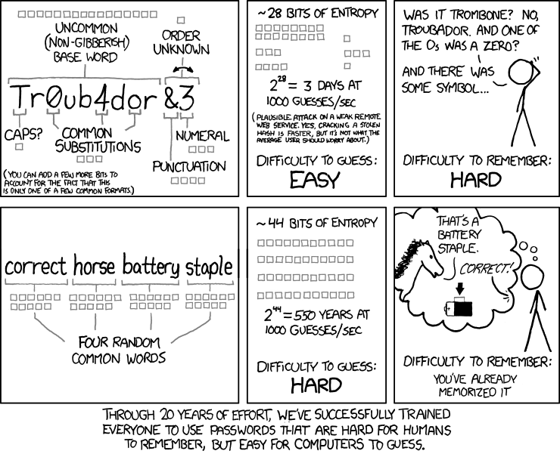

Questions
1. Encrypt the following words, using the key indicated:
a) correct (48) b) horse (37) c) staple (12)

2. Decrypt the following words and state the encryption key for each one:
a) 48/360/360/264 b) 330/1122/1386/66/1320/594/990/924
c) 324/54/162/1080/810/972 d) 81/972/567/405/162/1458/81
e) 78/26/312/78/546/312/26/520/390/468 f) 1136/355/1065/1136/852/355
g) 1400/70/1330/1400/350 h) 492/369/451/205
i) 195/520/585/195/715/325/910 j) 408/612/952/612/1292/544/340/272

Answers
1.
- 3 15 18 18 5 3 10 becomes 144 720 864 864 240 144 480
- 8 15 18 19 5 becomes 296 555 666 703 185
- 19 20 1 16 12 5 becomes 228 240 12 192 144 60

2.
- Book, key = 24
- Equation, key = 66
- Factor, key = 54
- Algebra, key = 81
- Calculator, key = 26
- People, key = 71
- Taste, key = 70
- Like, key = 41
- Chicken, key = 65
- Finished, key = 68

Proportion problems
Common problems involve examining how proportions change. These are trivial when there are only two variables to consider.
For example, a person owns 2 dogs and requires 3 cans of dog food. How many cans would they require if there were 6 dogs?
We just need to keep the numbers in the same proportion. This means changing the original value of the unknown amount by the same proportion as the other variable.
Dogs Cans
2 3
6 x
We can see that the number of dogs changed by a factor of 3, therefore the number of cans also needs to change by a factor of 3.
Therefore, the owner needs 3 x 3 = 9 cans of food for 6 dogs.

However, what happens when there are more than two variables to consider?
For example, a person owns 2 dogs, and requires 5 cans of food to feed the dogs for 4 days. How many cans will that person need if they needed to feed one dog for 6 days?
Again, write this out in a structured format:
Dogs Cans Days
2 5 4
1 x 6
In cases like these, we simply scale up or down the known amount in the column being solved (cans in this case) by the changed proportion of the other columns. The number of dogs has decreased so the number of cans required will decrease, so we multiply by $\frac{1}{2}$. Similarly, the number of days has increased, therefore more cans will be required, so we multiply by $\frac{6}{4}$.
$x=5×\frac{1}{2}×\frac{6}{4}=3.75$ cans are required (or more accurately, 4, as we couldn’t buy part of a can)

Another example:
A person owns 2 dogs and requires 5 cans of food to feed the dogs for 4 days. How many days will 4 cans be able to last 3 dogs?
Dogs Cans Days
2 5 4
3 4 x
In this case, the number of dogs has increased, so the food will last fewer days, so we multiply by $\frac{2}{3}$. Similarly, the number of cans has decreased, so the food lasts fewer days, and we multiply by $\frac{4}{5}$.
$x=4×\frac{4}{5}×\frac{2}{3}=\frac{32}{15}≈2$ days

Questions
- If 12 girls earn $900 in six days, how much will 8 girls earn in 9 days?
- If six boys mow 6 hectares of grass in six days, how many hectares would ten boys mow in nine days?
- The fuel for ten gas fires costs $210 for eighteen days. What is the cost of gas for twelve gas fires for five days?
- Sixteen workers can make 800 boxes in nine days. How long will fifteen workers take to make one thousand boxes?
- Sarah earned $705.60 in the holidays, working nine hours a day for eight days (with no overtime paid). How much should she be paid if she works six hours a day for twenty days?
- A mower will cut ten hectares in six hours if it is driven at four kilometres per hour. How long will it take to cut fifteen hectares if it is driven at three kilometres per hour?
- Twenty-five men working eight hours a day remake a road in sixty-three days. How long would forty-five men take if they work seven hours per day?
- Twelve boys can dig all the potatoes in a paddock in ten days. How many days would it have taken fifteen boys to dig all the potatoes?
- A contract requires nineteen people to work 7.5 hours a day to complete a task in twenty-one days. If the boss is asked to complete the task in seven days, and he is able to use forty-five people on the job, how many hours will each person have to work each day?
- A contractor employs fifteen workers, each working an eight-hour day to complete a task in twenty-seven days. At the end of ten days, work has to be suspended for five days because a vital item of machinery has broken down. To finish the work on time, the contractor takes on more workers, and asks everyone to work an 8.5 hour day. How many more workers does the contractor employ?
- In a refugee camp, there are enough rations for 10,000 people for thirty-five days. After five days, 2,500 more refugees arrive. If everyone is now put on half-rations, how much longer will the food last?

Answers
- Girls Money Days
12 900 6
8 x 9
$$x=900×\frac{8}{12}×\frac{9}{6}=\$900$$
- Boys Hectares Days
6 6 6
10 x 9
$x=6×\frac{10}{6}×\frac{9}{6}=15$ hectares
- Fires Cost Days
10 210 18
12 x 5
$$x=210×\frac{12}{10}×\frac{5}{18}=\$70$$
- Workers Boxes Days
16 800 9
15 1000 x
$x=9×\frac{16}{15}×\frac{1000}{800}=12$ days
- Earnings Hours Days
705.60 9 8
x 6 20
$$705.60×\frac{6}{9}×\frac{20}{8}=\$1176$$
- Hectares Hours Speed
10 6 4
15 x 3
$x=6×\frac{15}{10}×\frac{4}{3}=12$ hours
- Men Hours Days
25 8 63
45 7 x
$x=63×\frac{25}{45}×\frac{8}{7}=40$ days
- Boys Days
12 10
15 x
$x=10×\frac{12}{15}=8$ days
- People Hours Days
19 7.5 21
45 x 7
$x=7.5×\frac{19}{45}×\frac{21}{7}=9.5$ hours/day
- Workers Hours Days
15 8 27 15 x 8 x 27 = 3240 hours in total
15 x 8 x 10 = 1200 hours completed
Requires 2040 hours in 12 days, at 8.5 hours/day.
2040 / (8.5 x 12) = 20 workers needed
Therefore 5 extra workers need to be employed.
- People Days
10000 35
After 5 days, 30 days of rations are left.
Days = $\frac{10000}{12500}×30×2=48$ days

Modulus arithmetic
Modulo arithmetic is the arithmetic of remainders. In fact, arithmetic modulo 5 is the arithmetic of remainders after division by 5, arithmetic modulo 9 is the arithmetic of remainders after division by 9, etc.
For mod 5 arithmetic, all the numbers ….,25, 20, 15, 10, 5, 0, -5, -10, -15, …. are regarded as being equal as they all have the same remainder after division by 5, namely 0. This group of numbers is called the residue class 0 in mod 5.
Likewise the numbers…..26, 21, 16, 11, 6, 1, -4, -9, -14,….. are referred to as the residue class 1 in mod 5, as they all leave remainder 1 after division by 5. We can construct residue classes 2, 3, 4 in similar fashion.
We should consider negative numbers give the remainders suggested as well. See below how when -4 is divided by 5, the remainder is 1.
-1
---------
5 ) -4
-5
------
1
To abide by the rules of normal division the arrowed number has to be less than the one above it. To achieve this, we need a quotient of -1, thus giving a remainder of 1. It pays to keep this important little fact in mind for the work later on.
When we are doing remainder work, all answers are functions of the individual remainders in the numbers concerned. The remainders are not related in any way to the size of the numbers. Accordingly, we can replace a number with a smaller one carrying the same remainder. i.e. one from the same residue class.

Example 1: What is the remainder when 672 + 134 is divided by 5?
Now 672 carries a remainder 2, and 134 carries a remainder 4 when divided by 5. Then their addition will carry a remainder 2+4 when divided by 5.
However, 6 is not a permissible remainder, but 6 itself has remainder 1 when divided by 5.
So, the remainder when 672+134 is divided by 5 is 1.

Example 2: What is the remainder when 34 x 41 is divided by 9?
34 carries a remainder of 7 when divided by 9, and 41 carries a remainder of 5, so the product of these numbers carries a remainder of 7 x 5 = 35 which in turn carries a remainder of 8.
Therefore, 34 x 41 has remainder 8 after division by 9.

Symbolism: The symbol is used in modulo arithmetic when we wish to indicate that two numbers/expressions have the same remainder
‘’ means ‘has the same remainder as’

The working for Example 1 above should be written as follows:
672 + 134 2 + 4 (mod 5)
= 6
1
The remainder is 1

For Example 2:
34 x 41 7 x 5 (mod 9)
= 35
8
The remainder is 8.

Example 3: What is the remainder when 3485 is divided by 3?
Consider that 3485 = 3 x 1000 + 4 x 100 + 8 x 10 + 5 x 1.
Now all the powers of 10 belong to residue class 1 in mod 3, so they can all be replaced by 1 in the above equation from a remainder point of view.
3485 3 x 1 + 4 x 1 + 8 x 1 + 5 x 1 (mod 3)
20 (which is equal to 2 x 10 + 0 x 1)
2 + 0
2
Remainder is 2.
The same process would apply for divisibility by 9, as again, all powers of 10 are equal to 1 in mod 9.

Example 4: What is the remainder when 17865 is divided by 9?
17865 = 1 x 10000 + 7 x 100 + 8 x 100 + 6 x 10 + 5 x 1
1 x 1 + 7 x 1 + 8 x 1 +6 x 1 + 5 x 1 (mod 9)
27
2 + 7
9
0
The remainder is 0, indicating 9 is a factor of 17865.

Example 5: What is the remainder when 24758 is divided by 11?
24758 = 2 x 10000 + 4 x 1000 + 7 x 100 + 5 x 10 + 8 x 1
In arithmetic mod 11, all the even powers of 10 have the same remainder as 1; eg 10² = 100 gives quotient 9 and remainder 1 when divided by 11.
On the other hand, the odd powers all have remainder 10 when divided by 11; eg 10³ = 1000 which gives quotient 90 and remainder 10 when divided by 11. But 10 can be equated with -1 in mod 11.

24758 = 2 x 10000 + 4 x 1000 + 7 x 100 + 5 x 10 + 8 x 1
2 x 1 + 4 x -1 + 7 x 1 + 5 x -1 + 8 x 1 (mod 11)
(8 + 7 + 2) – (5 + 4)
Odds - Evens
8
Remainder = 8.

Questions
Find the remainder for each operation, using modulus arithmetic and not a calculator
- 28 x 41 divided by 9
- 91 x 45 divided by 8
- 12389 + 3214 divided by 4
- 12345 divided by 9
- 12345 divided by 6
- 657 – 189 divided by 3

Answers
- 28 x 41 divided by 9
28 $≡$ 1, 41 $≡$ 5 in mod 9
1 x 5 = 5, therefore remainder will be 5
- 91 x 45 divided by 8
91 $≡$ 3, 45 $≡$ 5 in mod 8
3 x 5 = 15
15 $≡$ 7 in mod 8, therefore remainder will be 7
- 12389 + 3214 divided by 4
12389 $≡$ 1, 3214 $≡$ 2 in mod 4 (using divisibility rules to work this out quickly)
1 + 2 = 3, therefore the remainder is 3
- 12345 divided by 9
12345 = 1 x 10000 + 2 x 1000 + 3 x 100 + 4 x 10 + 5 x 1
12345 $≡$ 1 x 1 + 2 x 1 + 3 x 1 + 4 x 1 + 5 = 15
15 $≡$ 6 in mod 9, therefore the remainder is 6
- 12345 divided by 6
12345 = 12000 + 300 + 40 + 5
12345 $≡$ 0 + 0 + 4 + 5 = 9
9 $≡$ 3 in mod 6, therefore the remainder is 3
- 657 – 189 divided by 3
657 $≡$ 0, 189 $≡$ 0 in mod 3 (divisibility rules help here)
0 – 0 = 0, therefore the remainder is zero

Rates

Rates are measured in quantity (or distance) per time unit.

For example, velocity (speed) can be measured in kilometres per hour (km/h) or metres per second (m/s).

Similarly, production lines might produce items per hour.

For situations involving distance, velocity and time, it is useful to remember the formula:

Distance = Velocity x Time ($d=vt$)

E.g. Calculate the distance travelled by a car travelling at 60 km/h for 45 minutes.

The rate and the time need to use the same units, so we convert the 45 minutes to ¾ of an hour.

Now, $d=60×\frac{3}{4}=45 km$

This can be rearranged to calculate velocity or time as well.

E.g. Calculate the time it would take a car travelling at an average speed of 30km/h to travel 900m.

Again, the rate and the distance need to be in the same units, so we convert the 900m to 0.9km.

We rearrange the formula and substitute in our known values:

$$t=\frac{d}{v}$$$t=\frac{0.9}{30}=0.3$ hrs

Notice that the units of our solution match the units in the rate (hours). In this case, since 0.3 hours doesn’t make a lot of sense, we convert it to a more sensible 18 minutes (0.3 x 60).

Questions
Question 1
Anya flew from Kuala Lumpur to Singapore. The average speed for the journey was 248 km/h. The journey time was 1 hour 15 minutes. Work out the distance from Kuala Lumpur to Singapore.

Question 2
A plane flew 8740 km from Nairobi to Hong Kong. The flight time was 13 hours 15 minutes. Work out the average speed of the plane. Give your answer, in kilometres per hour, correct to the nearest whole number.

Question 3
An aeroplane flew from Qatar to Bahrain. The distance flown was 135 km. The average speed was 180 km/h. Work out the time taken. Give your answer in minutes.

Question 4
On Monday, Tarek travelled by train from Manchester to London. Tarek’s train left Manchester at 0835. It got to London at 1105 The train travelled at an average speed of 110 km per hour.
On Wednesday, Gill travelled by train from Manchester to London. Gill’s train also left at 0835 but was diverted. The train had to travel an extra 37 km. The train got to London at 1135.
Work out the difference between the average speed of Tarek’s train and the average speed of Gill’s train.

Question 5
On Monday, Nalim made a journey. On Tuesday, she made the same journey. Her average speed on Tuesday was 25% greater than her average speed on Monday. Calculate the percentage reduction in the time her journey took on Tuesday compared with Monday.

Question 6
Here is part of a timetable for the Paris to Montpellier express train service.
Paris | 0607 | 1007 | 1207 | 1807 | 2007
Valence | 0822 | 1224 | 1424 | 2024 | 2224
Nimes | 0909 | 1305 | 1505 | 2105 | 2305
Montpellier | 0937 | 1334 | 1534 | 2134 | 2334
The average speed of the 2007 train from Paris is 224 km/h. Work out the distance this train travels from Paris to Montpellier.

Question 7
The London airport is 200 miles from Manchester airport. A plane leaves Manchester airport at 10 am to fly to the London airport. The plane flies at an average speed of 120 mph.
What time does the plane arrive at the London airport?

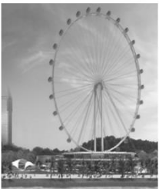
Question 8
The wheel of the Singapore Flyer is a circle with a diameter of 150 metres. The circumference of the wheel is 471 metres, correct to the nearest metre.
The wheel takes 30 minutes to rotate once.
Work out the average speed of a point on the circumference of the wheel as it rotates once. Give your answer in metres per second correct to 3 significant figures.

Question 9
The distance from Fulbeck to Ganby is 10 km. The distance from Ganby to Horton is 18 km.
18km
10km
Fulbeck Ganby Horton

Raksha is going to drive from Fulbeck to Ganby. Then she will drive from Ganby to Horton.
Raksha leaves Fulbeck at 1000. She drives from Fulbeck to Ganby at an average speed of 40 km/h. Raksha wants to get to Horton at 1035.
Work out the average speed Raksha must drive at from Ganby to Horton.

Question 10
The diagram shows a swimming pool in the shape of a prism.
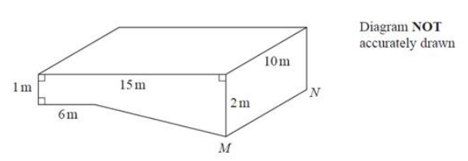
The swimming pool is empty. The swimming pool is filled with water at a constant rate of 50 litres per minute. Work out how long it will take for the swimming pool to be completely full of water. Give your answer in hours.

Question 11
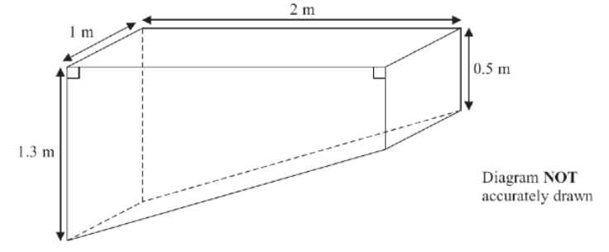
The pond is completely full of water. Sumeet wants to empty the pond so he can clean it. Sumeet uses a pump to empty the pond. The volume of water in the pond decreases at a constant rate. The level of the water in the pond goes down by 20 cm in the first 30 minutes.
Work out how much more time Sumeet has to wait for the pump to empty the pond completely.

Question 12
The diagram shows a container for grain.
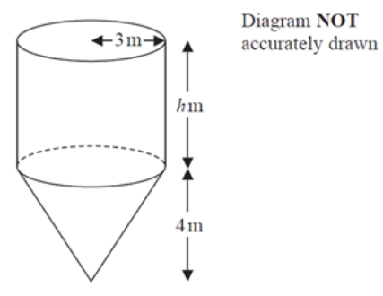
The container is a cylinder on top of a cone. The cylinder has a radius of 3 m and a height of ℎ m. The cone has a base radius of 3 m and a vertical height of 4 m.
The container is empty. The container is then filled with grain at a constant rate.
After 5 hours the depth of the grain is 6 metres above the vertex of the cone. After 9 hours the container is full of grain.
Work out the value of ℎ. Give your answer as a fraction in its simplest form. You must show all your working.

Answers
Question 1
$$d=248×1.25=310 km$$

Question 2
$$v=8740÷13.25=659.6=660 km/h$$

Question 3
$$t=135÷180=0.75 hrs=45 min$$

Question 4
Time taken on Monday = 2.5 hours
Distance from Manchester to London = $2.5×110=275 km$
Gill travelled $275+37=312 km$
Gill took 3 hours
Gill’s average speed = $312÷3=104 km/h$
Difference in average speeds = 6 km/h

Question 5
Using the formula for distance: $d=v×t$
Monday: $d=v×t_{M}$
Tuesday: $d=\frac{5}{4}v×t_{T}$
$$\frac{5}{4}v×t_{T}=v×t_{M} \\ \frac{5}{4}t_{T}=t_{M} \\ t_{T}=\frac{4}{5}t_{M}$$
Therefore, Tuesday’s journey took 4/5 of Monday’s time, which is 80%. The reduction was 20%.

Question 6
Train takes 3 hours and 27 minutes to make the journey.
$$d=224×3\frac{27}{60}=772.8 km$$

Question 7
$t=200÷120=1\frac{2}{3}$ hours
The plane arrives at 11:40am

Question 8
30 minutes = 1800 seconds
$v=471÷1800=0.262$ (3 sf)

Question 9
Time from Fulbeck to Ganby = $10÷40=0.25$ hours = 15 minutes.
So Raksha has 20 minutes to get from Ganby to Horton, or 1/3 of an hour.
$v=18÷\frac{1}{3}=54$ km/h

Question 10
Area of front face consists of a 1 x 6m rectangle and a trapezium with parallel sides of 1m and 2m that are 9m apart.
$$A=\left(1×6\right)+\left(\frac{1+2}{2}×9\right)=19.5 m^{2} \\ V=19.5×10=195 m^{3}$$
$$1 m^{3}=1000000 {cm}^{3}=1000000 ml=1000 L$$
Volume of pool = $195 000 L$
Time to fill the pool = $195000÷50=3900$ minutes = 65 hours
The diagram shows a swimming pool in the shape of a prism.

Question 11
Volume of full pond = $\left(\frac{1.3+0.5}{2}×2\right)×1=1.8 m^{3}$
Volume of pond with 20cm out = $\left(\frac{1.1+0.3}{2}×2\right)×1=1.4 m^{3}$
Therefore, 0.4 m³ has been drained in 30 minutes, which is 0.8 m³ per hour.
It would take $1.4÷0.8=1.75$ hours from now to drain the pool. This is 1 hour and 45 minutes.

Question 12
Volume of entire container = volume of cone + volume of cylinder
$$V=\left(\frac{1}{3}×π×3^{2}×4\right)+\left(π×3^{2}×h\right)=12π+9πh$$
Volume when depth is 6m above vertex (cylinder now has a depth of 2m):
$$V=\left(\frac{1}{3}×π×3^{2}×4\right)+\left(π×3^{2}×2\right)=12π+18π=30π$$
The rate at which the container is filling in m³ per hour = $30π÷5=6π m^{2}/hr$
It took 4 hours to complete filling the container. Therefore, there are an additional $24π m^{3}$ poured into the container.
Therefore, the total volume is 54π m³. Solving for h:
$$12π+9πh=54π \\ 9πh=42π \\ h=\frac{42}{9}=4\frac{2}{3} m$$

Ratio
A ratio tells of the relationship in quantity, amount or size between two or more things.
For example, if we had a bowl of fruit with 8 oranges and 5 apples, the ratio of oranges to apples would be 8 : 5.

Simplifying ratios
We generally want to write ratios in their simplest form. This is similar to simplifying fractions, in that we just look for common denominators between each part in the ratio.

E.g. Simplify the ratio 18 : 27
Since both are divisible by 9, we simplify to 2 : 3.
(We could have divided by 3, giving 6 : 9, but this wouldn’t be the simplest ratio.)

E.g. Simplify the ratio 2 hours : 40 minutes
First we have to convert to the same units, changing the ratio to 120 : 40.
Both are divisible by 40, so the ratio becomes 3 : 1.

Sharing in a given ratio
This occurs when we have an amount and need to split it into a given ratio. In this case, consider the fraction of the total amount that each ratio represents.
For example, in the ratio 2 : 3, there are 5 parts in total (2 + 3), and the first part of the ratio represents $\frac{2}{5}$ or them, while the second part represents $\frac{3}{5}$.
We can now find each fraction of the amount.

E.g. Split $120 into the ratio 2 : 3 : 5
In this case, there are 2 + 3 + 5 = 10 parts in the ratio.
This means we split the $120 into three fractions: $\frac{2}{10} , \frac{3}{10} , \frac{5}{10}$
$$120×\frac{2}{10}=\$24 \\ 120×\frac{3}{10}=\$36 \\ 120×\frac{5}{10}=\$60$$
Therefore, we split the $120 into $24 : $36 : $60

Questions
Question 1
Simplify these ratios:
a) 12 : 8 b) 34 : 51 c) 12 : 18 : 9 d) 84 : 42 : 56

Question 2
Share $60 in the ratio 5 : 1

Question 3
Share 32 sweets in the ratio 1 : 5 : 2

Question 4
Share 1 litre of juice in the ratio 7 : 3

Question 5
Maia and James split are paid for painting a fence. Maia worked longer hours so they agree to split the amount in the ratio 5 : 3. If Maia gets paid $75, how much will James be paid?
How much were they paid in total?

Question 6
Rachel has some apples and bananas. The ratio of apples to bananas is 2 : 3. She has 14 apples.
How many bananas does Rachel have?

Question 7
At a rugby match, the ratio of children to adults is 2 : 3. There are 80 children in the crowd.
Each adult ticket costs $8. Each child ticket costs a quarter of the adult ticket.
Work out the total money made from ticket sales.

Question 8
Charlene and Danielle share some money in ratio 2 : 3. Danielle gets $25 more than Charlie.
How much does each girl receive?

Question 9
The angles in a triangle are in the ratio 1 : 2 : 9. What is the size of the largest angle?

Question 10
4 schools sent students to a languages course.
One of the schools sent both French and German students. The ratio of French to German students it sent was 1 : 3. The school sent 21 German students.
The other 3 schools sent the same number of students.
Work out the total number of students sent to the languages course.

Question 11
A bag contains yellow and blue blocks in the ratio 1 : 3.
There are eight more blue blocks than yellow blocks.
How many of each colour are there?

Question 12
The ratio of boys to girls in a class is 2 : 3.
There are six more girls than boys in the class.
How many girls are there?

Question 13
In a survey, the ratio of the number of people who preferred tea to those who preferred coffee was 9 : 5.
36 more people preferred tea to coffee.
How many people were there in the survey?

Question 14
The ratio of Millie’s age to Heather’s age is 4 : 9.
Heather is 40 years older than Millie.
How old is Millie?

Answers
Question 1
a) 3 : 2 b) 2 : 3 c) 4 : 6 : 3 d) 6 : 3 : 4

Question 2
$$60×\frac{5}{6}=50 \\ 60×\frac{1}{6}=10$$
Ratio is $50 : $10

Question 3
$$32×\frac{1}{8}=4 \\ 32×\frac{5}{8}=20 \\ 32×\frac{2}{8}=8$$
Ratio is 4 : 20 : 8

Question 4
700 ml : 300 ml

Question 5
Maia’s fraction is $\frac{5}{8}$
Therefore, $\frac{1}{8}=15$
James’s $\frac{3}{8}=\$45$
They were paid 75 + 45 = $120 in total

Question 6
The fraction that is apples is $\frac{2}{5}$.
Therefore, $\frac{1}{5}=7$
The bananas are $\frac{3}{5}$, which is 21.

Question 7
$\frac{2}{5}$ of the crowd is 80. Therefore, $\frac{1}{5}=40$, meaning there are 120 adults.
Children’s tickets cost $2
Total money = $80×\$2+120×\$8=\$1120$

Question 8
The two fractions are $\frac{2}{5}$ and $\frac{3}{5}$. The difference between them is $\frac{1}{5}$. $\frac{1}{5}=\$25$
Therefore, Charlene receives $50 and Danielle receives $75.

Question 9
Split 180 into the ratio 1 : 2 : 9.
Fractions are $\frac{1}{12} , \frac{2}{12} , \frac{9}{12}$
$$180÷12=15$$
So the angles are: 15, 30, 135

Question 10
Fraction of German students is $\frac{3}{4}$.
If $\frac{3}{4}=21$, $\frac{1}{4}=7$
The school sends 7 French and 21 German students, so 28 in total.
$$28×4=112$$

Question 11
The difference between the two as a fraction is $\frac{3}{4}-\frac{1}{4}=\frac{1}{2}$
If $\frac{1}{2}=8$, then there are 16 blocks in total.
This means there are 4 yellow and 12 blue blocks.

Question 12
The difference between the two is $\frac{1}{5}$
If $\frac{1}{5}=6$, then there are 30 children in total.
Therefore, there are 12 boys and 18 girls.
Question 13
The difference between the two is $\frac{4}{14}=\frac{2}{7}$
If $\frac{2}{7}=36$, then $\frac{1}{7}=18$, and there are $18 ×7=$126 people in the survey.

Question 14
The difference between the two is $\frac{5}{13}$
If $\frac{5}{13}=40$, then their ages add to 104 (40 x 13/5).
Splitting into the ratio of 4 : 9, it means Millie is $104×\frac{4}{13}=32$

Starter problems covering ratio and measurement
Question 1
Two circles are stacked perfectly on top of each other, as shown below.
The ratio of their areas is 4 : 1, and the total area of the circles is 40cm². What is the combined height of the circles? Try to give the exact answer if possible, without rounding.
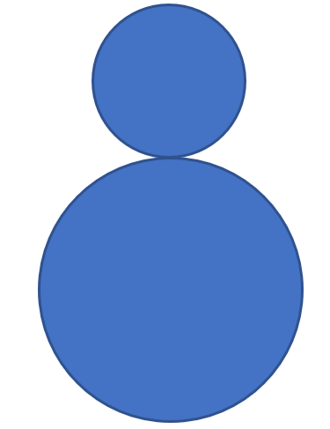

Question 2
Another two circles are stacked perfectly on top of each other. If the ratio of the two radii is 2 : 3, and their combined height is 80cm, what is the total area of the circles?
Try to give the exact answer if possible.

Question 3
If two squares have side lengths in the ratio 5 : 3, what is the ratio of their areas?

Question 4
If two cubes have side lengths in the ratio 5 : 2, what is the ratio of the volumes?

Question 5
If the two cubes have volumes in the ratio of 27 : 8, what is the ratio of their respective side lengths?

Question 6
A cone has volume 120π cm³. It is filled with water until nearly full, where the ratio of the heights of the filled part to the height of the empty part is 4 : 1.
What is volume of water in the cone?
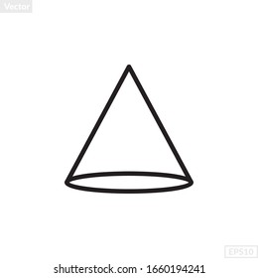
1
4

Answers
Question 1
Two circles are stacked perfectly on top of each other, as shown below.
The ratio of their areas is 4 : 1, and the total area of the circles is 40cm². What is the combined height of the circles? Try to give the exact answer if possible, without rounding.


Proportion occurs when we are trying to keep items in the same ratio. For example, if we have a recipe for a chocolate cake and we want to make two cakes, we have to multiply every ingredient by 2. In other words, everything must be multiplied (or divided) by the same amount to keep all of the parts in proportion.

For example:
A recipe to make 4 cup cakes requires the following ingredients:
2 eggs
250g of flour
100g of sugar
How much of each ingredient would be required to make 10 cup cakes?
There are two ways to think about this:
- Work out the proportional change from 4 to 10. 10 ÷ 4 = 2.5, therefore we just multiply all amounts by 2.5
$2×2.5$ = 5 eggs
$250×2.5$ = 625g flour
$100×2.5$ = 250g sugar
- Work out how much is required for 1 cup cake, then multiply everything by 10
$2÷4$ = ½ an egg
$250÷4$ = 62.5g flour
$100÷4$ = 25g sugar
Therefore we need 5 eggs, 625g flour, 250g sugar (multiplying each by 10)
You need to be comfortable using either method, as sometimes the proportional change will not be a neat number like 2.5.

Direct proportion
This means that as one value increases, so does the other. The recipe question above is an example of direct proportion. In other words, as we increase the number of cup cakes required, the amount of each ingredient also increases, and by the same proportion.

Inverse proportion
This means that as one value increases, the other decreases.
For example:
One person can dig a 1m³ hole in 4 hours.
How long will it take two people? 2 hours
How long will it take four people? 1 hour
How long will it take eight people? ½ hour

Questions
A fruit punch for 20 glasses requires the following ingredients:
1 L of orange juice
600ml of apple juice
250ml of cranberry juice
350ml of grapefruit juice
How much of each ingredient would be needed for 75 glasses?

